Lab 2 - Troubleshooting

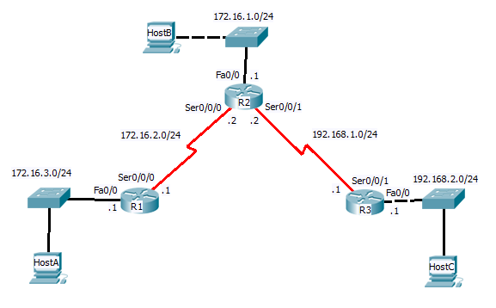

Instructions:

- Download Troubleshooting.pkt
- Find the 10 errors and make the appropriate corrections.
- Problems may be cabling, router configurations, host configurations

Verifications:

- Host A should be able to ping Host B and Host C
- R1 should be able to telnet into R3
1. Device: ______R1_________

Error: __FastEthernet0/0 interface shutdown___________________________________

Correction: ________Enabled interface using no shutdown_______________

2. Device: ______R1_________

Error: _________________________Incorrect IP address on Serial interface_________________________________

Correction: ________Configured correct IP 172.16.2.1 /24__________________________________

3. Device: __________R2_____

Error: ____________________________Incorrect static route configuration______________________________

Correction: _____________________________Added correct static routes_________________________
R3

4. Device: ______ _________

Error: ___________________________ _______________________________

Correction: ___________________ ___________________________________

5. Device: ________R3_______

Error: __________________________FastEthernet interface shutdown________________________________

Correction: ____________________Enabled interface using no shutdown__________________________________

6. Device: ________R3_______

Error: ________________Incorrect static route to left network__________________________________________

Correction: __________________Configured correct static route____________________________________

7. Device: ______S2_________

Error: _Port connected to PC2 was shutdown_________________________________________________________

Correction: _______________Enabled port using no shutdown_______________________________________

8. Device: ________ PC3_______

Error: ______________________ Incorrect default gateway____________________________________

Correction: _______________ Configured gateway 192.168.2.1_______________________________________

9. Device: _________ PC1______

Error: ___________________Incorrect default gateway_______________________________________

Correction: _______________Configured gateway 172.16.3.1_______________________________________

10. Device: _______PC2________

Error: ___________________________Incorrect IP configuration_______________________________

Correction: __________________Configured correct IP address and gateway____________________________________

